**Node js life cycle:**

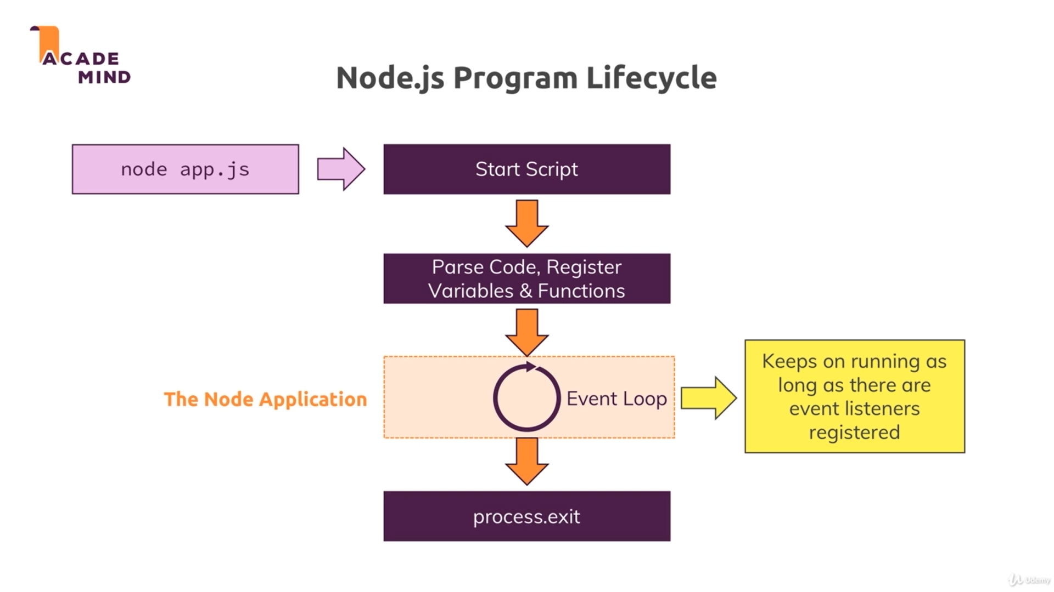

Process.exit(); shut down the server execution and it’s a **hard coded** process. When nodejs find this function then nodejs things nothing to execute and close the server and the result in visitor will never enter the website.

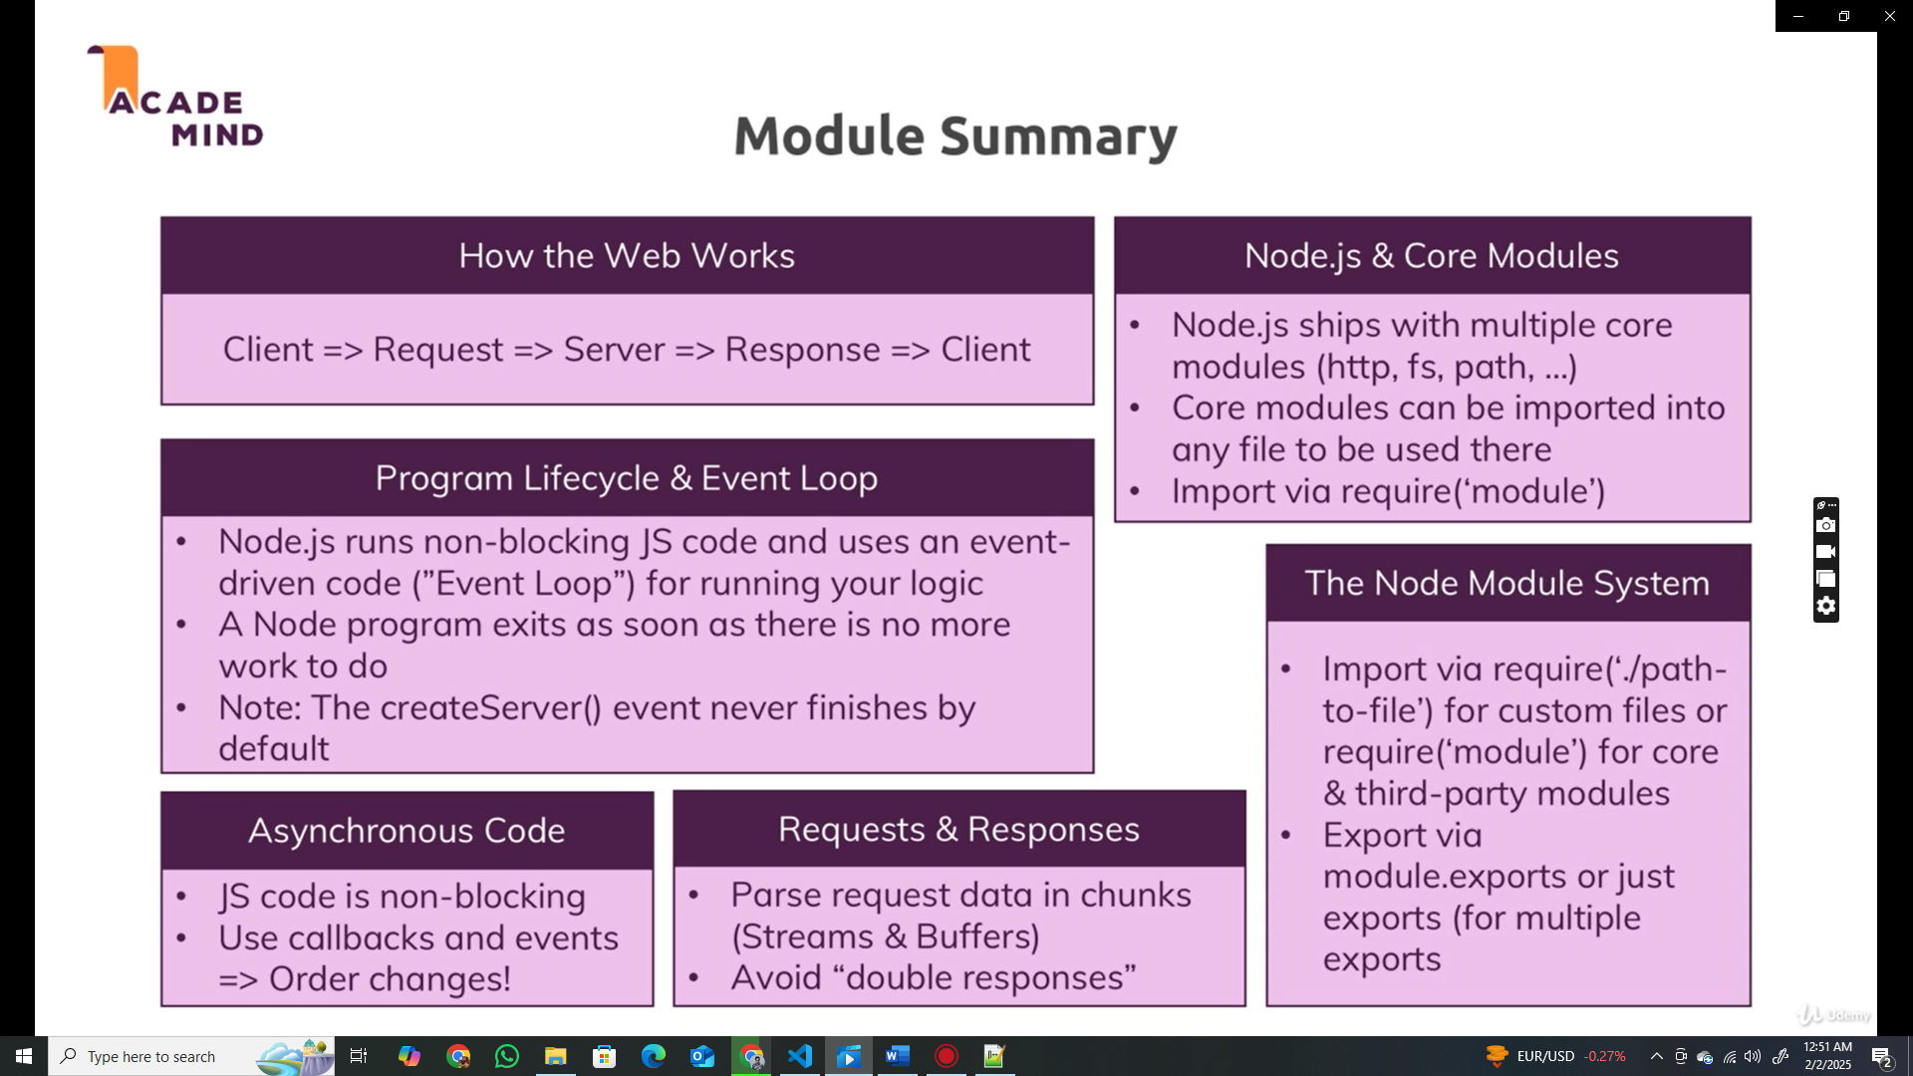

**Types of error that may face in node application:**

